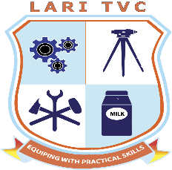

LARI TECHNICAL AND VOCATIONAL COLLEGE
P.O. BOX 10-00222 UPLANDS, KENYA
Email: lari1tvc@gmail.com
Mobile: 0798 595 756

LARITVC /ADM /F004
STUDENT DECLARATION FORM
This is to confirm That I
NAME (in full) ……………………………………………………………………………………
(SURNAME) OTHER NAME(S)
ADM NO: ………………………………………………………………………………………….
COURSE: ………………………………………………………………………………………….
ID NO: ……………………………………………………………………………………………..
Am an adult of sound mind and that I have read and clearly understood the guidelines given and fully agree with the content and that I shall, throughout my stay at LARI TVC, abide by all the college’s policies and students guidelines. I also agree that the Board of governors reserve the right to effect whatever changes they may deem fit within LARI TVC
SIGNATURE: ………………………………………………….. DATE: …………………
Witnessed by (Parent/ guardian/sponsor)
NAME (in full): ………………………………………………………………………………
ID NO: ……………………………………………………………………………………….
SIGNATURE: ………………………………………… DATE:…………………………
Witnessed by (HOD/Deputy HOD/Lecturer)
NAME (in full): ……………………………………………………………………………………
DESIGNATION: ………………………………………………………………………………….
SIGNATURE: ………………………………… DATE: ……………………………………..

